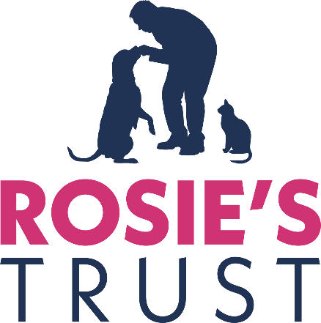

RECRUITMENT PACK
TREASURER, BOARD OF TRUSTEES

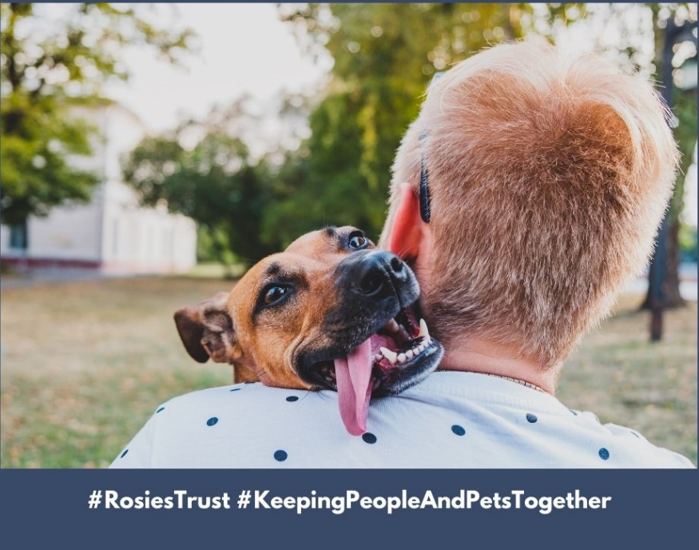

February 2024

Contents Page

Who we are, what we do 3
Our story 5
Organisation Chart 6
Role and responsibilities of the Treasurer/Trustee 7
Selection Criteria 7
Application process 7

Who we are and what we do
When someone is faced with a cancer diagnosis, disability or terminal illness, their whole world changes. They have so much to worry about, so much to deal with and the one thing they need - especially those living alone – is the emotional support that their companion pet provides.

They are no longer able to provide their dog or cat with the same level of care they once could and their anxiety about the welfare of their beloved companion only serves to compound their distress.

At the most stressful time of their lives, they may be forced to give up their companion pet and, in so doing, experience tremendous loss, isolation and feelings of guilt.

Some people have reported that they considered delaying or even refusing treatment because they had no one to look after their pet.

Rosie’s Trust is Northern Ireland’s only charity dedicated to helping the terminally ill, people undergoing cancer treatment, or older people with a disability hold on to their beloved pets. We care for our beneficiaries’ companion dogs and/or cats in their homes when they are no longer able to look after them independently.

Subject always to our beneficiaries’ wishes, we can provide fostering services when they need to spend a period of time in hospital or in hospice care. We can also find new homes for their pets when the beneficiaries are no longer able to care for them, including when they die.

Rosie’s Trust also offers a pet bereavement service, providing emotional support to beneficiaries when their companion pet predeceases them.

We provide our services free of charge, 365 days of the year. We depend on donations to cover our service costs, and every penny gifted to us is carefully used.
Our services offer peace of mind for our beneficiaries as they know Rosie’s Trust will support them in the care of their companion pet for as long as they need us and our resources permit.
Rosie’s Trust services not only help to address loneliness and social exclusion in Northern Ireland, but also to promote animal welfare, in accordance with the Welfare of Animals Act (NI) 2011.
Extensive network of volunteers
Our full-time staff of three are supported by a team of 150+ committed volunteers who are the lifeforce of Rosie’s Trust. They provide help and support in all aspects of pet care, including feeding, grooming, exercising, play and stimulation, and vet visits. Our volunteers are our eyes and ears, ensuring when they visit that our beneficiaries are as well as can be and providing welcome social contact for many. Our volunteers work in teams, with each member making two visits a week.

Our volunteers receive intense training before being matched to a beneficiary. This ensures they all have a sound understanding Rosie’s Trust’s policies and procedures to promote the health and wellbeing of our beneficiaries, their pets and the volunteers themselves. They are also trained to signpost to partner organisations, wherever necessary.

Since our establishment in 2015, we have served 180+ beneficiaries. Currently we serve 40 beneficiaries, located in four of the five Health and Social Care Trusts (Belfast, Northern, Southern and South Eastern).
We made a successful application to the Dormant Accounts Fund for £100,000 in late 2022. These funds are being used over two years to engage experienced Fundraising and Communications and Engagement professionals to future proof Rosie’s Trust and help achieve the objectives of our Strategic Plan 2022-2025 (attached).
We also received a three-year grant (People and Communities) from the National Lottery Community Fund in April 2023.
Our Values
#Compassion #Integrity #Inclusiveness #Respect #Quality #Partnership #Confidentiality

Our story
The original idea for Rosie’s Trust was born in 2015 when our founder, Bronagh O’Neill (pictured here with her dog, Rosie), who was a nurse at the time, learned first-hand from a friend of hers the impact that cancer had had on his ability to look after his beloved dog. He lived alone and described how he could no longer care for his “very special friend”.
Through subsequent research and discussions with organisations such as Marie Curie, Macmillan Cancer Support, Age NI and local Health and Social Care Trusts, Bronagh also learned that large numbers of people were having to surrender their pets at a time when they needed them most because they were too weak to care properly for them themselves.
Bronagh’s findings demonstrated to her the pressing need for a charity such as Rosie’s Trust in Northern Ireland. Since its establishment, Rosie’s Trust has worked with an increasing number of individuals and organisations (statutory, corporate as well as community and voluntary sector) to ensure we are continuing to provide the care and support that is required.

ROSIE’S TRUST
ORGANISATION CHART

Board of Trustees
(Chair: Aileen Martin)
All volunteers

Finance Manager (currently being recruited – 7 hours per week)

Marketing and Communications Lead ¹ (Claire Smyth – 21 hours per week)

CEO
(Catriona Mac Arthur – 14 hours per week)

Community Engagement and Fundraising Lead ¹ (Nuala Muldoon – 21 hours per week)

Development Officer
(Laura Quinn – full-time)

Operations Manager
(Jayne McStay –
full-time)

Volunteer Support Officer
(Sandra McFadden –
full-time)

- Both positions - Marketing and Communications Lead and Community Engagement and Fundraising Lead – are funded for two years (to 2025) through the Dormant Accounts Fund, administered by the National Lottery Community Fund. Other positions are funded for three years (to 2026) by the National Lottery Community Fund (People and Communities grant programme).

Role and responsibilities of the Treasurer, Board of Trustees
The Treasurer/Trustee to oversee the monitoring of the charity’s finances on behalf of the Board of Trustees, reporting regularly on them to the Board, and making sure that money and property are properly managed. A qualified accountant, the Treasurer/Trustee will ensure that bookkeeping, record keeping, and budgeting are done properly.
Specific responsibilities include:
- Ensuring proper systems are in place for budgeting, financial control and reporting.
- Overseeing and monitoring procedures to reduce the risk of fraud.
- Keeping all Trustees properly informed about the state of the charity’s finances.
- Ensuring financial reports to the trustees are comprehensible and properly discussed.
- Ensuring accounts and other financial reports are produced in the proper form and on time as required by, for example, the Charity Commission.
- Overseeing communications with the independent examiner.
- Monitoring the overarching strategic management of the organisation’s financial resources, and report to the CEO and the Board.
- Overseeing the charity’s financial risk-management process and reporting to the Board at regular intervals on the charity’s financial health.
Selection criteria
- Qualified Accountant (ACA/ACCA/CIMA)
- Minimum five years’ experience
Application Process
If you would like to apply for the position of Treasurer/Trustee with Rosie’s Trust, please send your CV together with a cover letter outlining how you meet the selection criteria, the skills and experience that you would bring to Rosie’s Trust, explaining your interest in the position.
Please send this documentation to catriona@rosiestrust.org by 5.00pm, Monday 26 February 2024.

